Annual General Meeting 2019

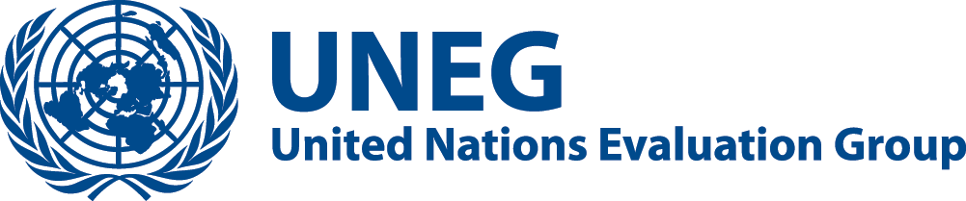
UNEG Strategy 2020-2024

Draft

Dates: 16-17 May 2019
Location: Room 3, UN Gigiri Compound, Nairobi
Hosts : United Nations Environment Programme (UNEP) and United Nations Human Settlements Programme
This report was prepared by the UNEG Strategic Planning Working Group. The draft was circulated to UNEG Heads on 26th April. It is being presented for discussion during the UNEG Strategic Plan 2020-2025 session at the AGM.

Contents
Foreword 3
Introduction 4
Agenda 2030 and the repositioning of the United Nations system 5
UNEG vision and mission 8
Theory of Change 9
Strategic Objectives 2020-2024 10
SO1: Setting and safeguarding professional norms, standards and relevant guidance for the United Nations system 11
SO2: Greater professionalization of its membership 11
SO3: Influencing policy-making and operational work through evaluations 12
Implementation, monitoring and evaluation 14

Foreword
[TBD]

Introduction
- The United Nations Evaluation Group (UNEG) has come a long way, having been established as an inter-agency network 35 years ago. Initially it was called the Inter-agency Working Group for evaluation (IAWG) and had just 18 members operating informally. Today UNEG has 48 agencies and operates in a more formal manner. Some milestones mark our evolution; in 2005 the first norms and standards was an important milestone, the process that began in 2007 for peer reviews provided support for evaluation functions and offices and the adoption of Ethical guidelines and Code of Conduct in 2008 further enhanced our professionalism and was an important iteration of the UNEG.
- In 2010 and 2012, UNEG moved towards greater exchanges with communities of practice and recognized our need to also help strengthen national evaluation systems, which was highly appreciated by Member Nations and helped advance evaluation at the country level. In 2013, we adopted our first multi-year strategy for UNEG for the period 2014-2019, to increase our strategic focus and effectiveness. In the adoption of the strategy, we built in a mid-term review, results of which are informing our current discussions.
- A critical milestone was our adoption in 2016 of revised UNEG Norms and Standards, which emphasize the principles of independence, credibility and utility, and made important inputs to how evaluation functions should be governed, funded and managed. We are very pleased to note several agencies refer to this document in enhancing their own evaluation policies, in a manner that better reflects evaluation as a profession that promotes learning, transparency and accountability.
- It has not been an easy process getting more robust evaluation functions in the United Nations system, and a strong UNEG is necessary to support our function, which is essentially providing critical oversight, for more robust debates and program improvement. It is aligned to the overall commitment of the United Nations as being more transparent and accountable, and the 2016 stipulation of many key elements of evaluation, such as financial benchmarks, reporting lines and prevention of bias have been important.
- This document reflects the diversity and strength of our membership and shows how well the members have offered their expertise and experience to create a better UNEG, for a better United Nations, to ensure a more robust performance narrative at all levels. We are very pleased to be consulted in the United Nations repositioning process and stand ready to support the process from our collective vantage points, which spans the full spectrum of United Nations operations across the globe, as our contribution to the Agenda 2030.

Agenda 2030 and the repositioning of the United Nations system
- The complexity of the 2030 Agenda, including the interlinkages between the Sustainable Development Goals (SDGs), are challenging the United Nations evaluation community like never before. They are placing heavy demands on already stretched United Nations evaluation offices whose main focus is their Agency’s work. At the same time, the impact of system-wide reform and system-wide agendas can only be assessed through system-wide evaluation efforts. The reform therefore presents a unique opportunity for UNEG to inform system-wide policy-making and promote the use of evaluation at organization and system-wide level.
- UNEG has been promoting the need for system-wide evaluation capacity since 2008. However, early efforts failed. The 2013 Policy of the United Nations Secretary-General on the Independent System-wide Evaluation of Operational Activities for Development of the United Nations System (ISWE) was an important step recognizing the need for more system-wide evaluation, but the pilot phase was marred by a lack of funding and reporting platforms. They nevertheless showed the potential value-added of a system-wide evaluative voice.
- This was picked up by the Secretary General in his seminal report on “Repositioning the UN Development System” in July 2017. Recognizing that the system needed a game changer to remain relevant and deliver on its support to Governments in the implementation of the 2030 Agenda, the Secretary-General, among many other proposals, also indicated his intention to set up a small independent system-wide evaluation unit. The Secretary-General had also proposed a funding dialogue to look at how the United Nations development system is funded, resulting in discussions in early 2019 to establish a Funding Compact (FC) to give the United Nations system a more stable basis to meet the ambitious goals and timelines set out in the 2030 Agenda.
- Evaluation features strongly in the FC as not only a means to increase transparency but also as a means to obtain independent and credible feedback on performance. In many aspects, the FC has triggered a high interest by Member Nations, as well as the Secretary-General’s Office, in UNEG’s work and high expectations that UNEG is able to deliver on improved transparency and joint/system-wide evaluative evidence. The FC affects all the areas of our strategic plan and how they need to be pursued in the future:
  - increased joint and system-wide evaluations by UNEG members (FC commitment 2);
  - improved quality of UN Development Assistant Framework (UNDAF) evaluations (FC commitment 8); and
  - greater transparency through publication of UNEG member reports on UNEG’s website by SDG (FC commitment 9).
- In parallel, the repositioning vision of the Secretary-General focuses on an empowered and more effective resident coordinator system guided by a strategic United Nations Development Framework. The need for more robust and credible UNDAF evaluations had been highlighted by the ISWE pilot conducted in 2016. UNDAF evaluations will most likely remain decentralized evaluations managed at the country level. UNEG is expected to spearhead the development of guidelines, training, and quality assurance mechanisms in order to safeguard the objectivity and credibility of these exercises.
- Discussions surrounding the development of the FC also touched upon means of achieving the commitments and led to the development of a roadmap for implementing the Secretary-General’s vision of a system-wide evaluation capacity. While this builds on what UNEG has to offer as a professional network, including its norms and standards, the roadmap also includes the updating of the 2013 policy on independent system-wide evaluation, the establishment of a secretariat/unit in charge of coordinating/managing ISWE activities and the development of a multi-donor trust fund to ensure future funding for system-wide evaluations. UNEG was also asked by the Executive Office of the Secretary-General (EOSG) to second a senior staff to help develop and start up the architecture with funding being provided by a Member Nation for the first year of activities.
- Looking ahead there are a number of key opportunities for UNEG in the era of the SDGs (matching Strategic Objectives are in parentheses):
- Better planning and publication of evaluative work. A modest beginning would be for UNEG to map future plans for single and joint evaluations categorized by SDG and by country. A further step would be to ensure that these ask the same key questions and collect pre-defined data to, in turn, inform system-wide analysis. Such a mapping will help forge partnerships at the country and global levels. However, given the limited resources available for this kind of work, which is currently only seen as a sporadic add-on, any increase will likely remain marginal unless incentive systems are developed, including demand and interest by policy makers. All of this will require that national and global partners beyond the United Nations step up to the plate. [SO3]
- Meeting demand for meta-evaluation and meta-synthesis of existing evaluative work - including beyond the United Nations - is most likely to increase. These tend to be the least costly system-wide evaluation products. The challenge here will to be ensure that the bulk of evaluations used for the synthesis work are sufficiently robust and allow a degree of specificity. [SO3]
- Engaging systematically in joint and System-wide Evaluation (SWE): one way to increase these would be for members to create “coalitions” of those agencies that have significant work in a specific area. A good example for this is the new UNAIDS coalition that brings together the 13 co-sponsor evaluation units of UNAIDS to engage on assessing performance of the mid-term strategy. SWEs could be prepared for the annual discussions of the voluntary national reports during the High Level Political Forum (HLPF) or other relevant fora. [SO 3]
- Developing methodological and process guidance as well as supporting SDG and UNDAF evaluations will be one of UNEG’s main strategic engagements in the coming years. This must be done in partnership with other actors including academia, international organizations, national governments, regional evaluation associations, civil society and so forth. The complexity of SDG-era evaluation is well recognized but not tackled. There is currently no clarity nor common understanding. This is also evidenced in the recent discussions on how to revise the DAC evaluation criteria so they are fit for purpose. All of this will require an international dialogue and joint action. [SO1]
- Building our own capacities but also those of our partners. New methodological approaches will require updating the skills set of our own staff as well as a more robust decentralized evaluation capacity. Building national evaluation capacities should be an integral part of our evaluation efforts. As a network we need to pool resources at country level in collaboration with regional evaluation networks and training providers. [SO2]
- Effectively communicating evaluative evidence. In order to meet the increased demand for system-wide evaluation knowledge UNEG needs to seek to present joint and system-wide reports at relevant inter-governmental discussions, e.g. the HLPF. [SO3]
- Ensuring that the new architecture is fit for purpose. This includes ensuring a clear mandate for an SWE office, right size/right location, close engagement with UNEG, the development of a funding instrument, and ability to produce and table independent SWE reports in the appropriate fora.

UNEG vision and mission
- Our Vision: UNEG envisions that evaluations within the United Nations System produce knowledge and evidence used to inform relevant, coherent, sustainable, effective and efficient delivery towards the achievement of the Agenda 2030, contribute to good governance and oversight of the United Nations system, and positively impact the lives of the people we serve.
- Our Mission: UNEG’s mission is to promote, strengthen and advocate for a robust, influential, independent, innovative, and credible evaluation function throughout the United Nations system to support decision-making, accountability and learning. UNEG aims to:
- Safeguard and influence the quality of evaluation practice in the United Nations system
- Support the professionalization of its membership
- Advocate for the use of evaluations in policy-making and operational work of the United Nations system and beyond.
- Facilitate partnerships and collaboration on evaluation in the United Nations system and beyond.

Theory of Change
- In order to ensure strategic alignment and the connection between the UNEG Strategy and its members’ needs and priorities, as well as with the United Nations system-wide initiatives and to the Agenda 2030/SDGs, a Theory of Change has been developed as a tool to summarize and communicate internally and to all UNEG stakeholders, how UNEG’s vision, mission, strategic objectives and key areas of action are part of and contribute to the way forward to an inclusive and sustainable global development process.
- The Theory of Change, as presented in appendix 1, is a living document that might be updated at any moment, to further reflect, recollect and ensure that the UNEG’s strategy remains aligned to the larger picture and the way forward to achieve the SDGs.
- The Theory of Change seeks to foster the development of a theory of change across the pillars of the United Nations system, with explicit preconditions and assumptions to be considered and/or monitored. Expanded ownership and use of the Theory of Change by UNEG members is encouraged to enhance a common understanding and sharing of UNEG’s strategic perspectives by all members.

Strategic Objectives 2020-2024
- To achieve its mission, UNEG’s work is focused on three strategic objectives (SO):
  - SO1: Setting and safeguarding professional norms, standards and relevant guidance for the United Nations system;
  - SO2: Greater professionalization of its membership; and,
  - SO3: Influencing policy-making and operational work through evaluations.
- Partnerships and collaboration on evaluation are considered major enablers of UNEG’s work, and as such contribute to the achievement of the three SOs.
- This strategy is a framework to guide UNEG’s work. Each SO has a series of key areas of action that are intended to lead to an outcome, as illustrated in UNEG’s Theory of Change.
- With the oversight and support of UNEG’s Executive Steering Committee, the associated Strategic Objective working and interest groups will articulate how their activities are aligned to the key priority actions and how they will ultimately contribute to UNEG’s outputs and outcomes.

SO1: Setting and safeguarding professional norms, standards and relevant guidance for the United Nations system
- Setting and updating norms and standards for evaluation in the United Nations system has been a core business of UNEG since its foundation. The UNEG Norms and Standards for Evaluation, adopted in 2005, have served as a landmark document for the United Nations and beyond. For almost fifteen years, these have been used successfully to strengthen and harmonize evaluation practice, and has served as a key reference for evaluators across the globe.
- In 2016, UNEG adopted an updated set of Norms and Standards, which reflect an evolving context and increasing demands for accountability and national ownership. The ten general norms should be upheld in the conduct of any evaluation; the four institutional norms should be reflected in the management and governance of evaluation functions. The five associated standards support the implementation of these normative principles.
- UNEG promotes adherence to the norms and standards through the external review processes of evaluation functions, and the development of relevant guidance materials. Despite ongoing initiatives to expand the coverage of peer reviews, and to develop new guidance materials, future work in this area continues to be necessary. Besides, the increasing recognition of the Norms and Standards, and their application to decentralized and UNDAF evaluations, will require the development of relevant guidance materials (under SO3) as well as the preparation and implementation of specific training packages for a variety of stakeholders (under SO2).

Key areas of action
- Under SO1, UNEG and its members would collectively further enhance and safeguard evaluation functions through, inter alia:
- Promoting and updating the norms and standards, with a focus on developing products, guidance and services to support their use;
- Facilitating adherence to UNEG norms and standards through self-assessments and external review of evaluation functions.

Key Performance Indicators
- By 2021, 100 percent of UNEG norms and standards have guidance materials to support their use, and facilitate the conduct of validated self-assessments/external reviews. Baseline (2019): TBD;
- By 2024, 100 percent of UNEG members have made progress in adhering to UNEG norms and standards, as confirmed through validated self-assessment or external review of their evaluation functions within the past five years. Baseline (2019): 0.

Associated working/interest groups
- Peer Reviews | - Ethics
- Human rights and gender equality

SO2: Greater professionalization of its membership
- Professionalism of evaluators is grounded in the view that evaluators belong to a cadre of professionals, with multidisciplinary backgrounds and experience, but united in their commitment to the norms and standards that govern the profession. In UNEG, these principles are part of UNEG Norms and Standards (2016) which govern all aspects of the profession, and is explicit about the roles and responsibilities of parties in the evaluation process, and also stipulates the rights and obligations of both evaluators and evaluands.
- The key principles for professional evaluators is adherence to independence, as a professional obligation given the judgment orientated nature of work, and both perceived and actual conflict of interest is important in terms of evaluators’ conduct. These principles allow professional evaluators to operate impartially, to access all parties involved in the evaluation, and to exercise the right to debrief all parties, with due sensitivity to principles of confidentiality.
- The first obligation of evaluators is to the evaluation policy and professional disposition required, before that of the institution it serves. The principle of credibility in evaluation relates to the designing of inclusive evaluation processes, with robust and defensible methodology (both process and analytical), allowing for judgements to be made from a sound evaluation basis. It requires sound expertise in the evaluation and subject-field, and should have adequate review processes to test findings, and ensure proper triangulation. Of critical importance to evaluators is use, or utility. It is necessary for professional evaluators to understand decision-making and organizational processes, so that findings are relevant, targeted and actionable.

Key areas of action
- Under SO2, UNEG and its members would collectively and individually achieve greater professionalism through, inter alia:
- The development and adoption of a professional competency framework for United Nations evaluators that is aligned with the 2016 UNEG norms and standards;
- Annual cutting-edge EPEs and professional workshops in the margins of the AGM emphasizing key elements of professionalization; and,
- Tailored learning services for UNEG members, evaluation managers in decentralized functions and partners.

Key Performance Indicators
- By 2021, a competency framework for United Nations evaluators is adopted, and tailored learning services for core evaluation competencies are rolled out. Baseline (2019): TBD;
- By 2024, 100 percent of UNEG members formally use the UNEG competency framework for staff recruitment and performance assessment. Baseline (2019): 0 percent.

Associated Working/Interest groups
- Professionalization | - Evaluation Professional Exchange
- Evaluating policy influence

SO3: Influencing policy-making and operational work through evaluations
- The objective is to enhance the influence of evaluations within and outside the United Nations system. This would lead to evaluations making greater contributions to organizational learning, informed decision-making processes and accountability for results (UNEG Norm 2). Building on past efforts, UNEG now has an excellent opportunity to enhance the influence of evaluations through the United Nations System Repositioning process, both at headquarters and in the field, as well as through solidified partnerships with the global evaluation community.

Key areas of action
- Under SO3, UNEG and its members would collectively and individually achieve this objective through, inter alia:
- supporting the development of policy frameworks, institutional set-ups and governance, normative standards and methodological guidance (e.g. system-wide evaluations, system-wide evaluation architecture, UNDAF evaluations, new types of joint evaluations);
- engaging and presenting to governing bodies, member state governments, management apparatus, and other key stakeholders within and outside the United Nations system;
- setting up and promoting the evaluation agenda of interest to stakeholders, and developing common methodologies and approaches (e.g. SDG evaluations, humanitarian evaluations, evaluations to “leave no one behind”)
- constituting evaluation coalitions to support/coordinate joint or system-wide evaluation efforts and products relevant for each SDG as well as other system-wide agendas (e.g. humanitarian assistance);
- providing practical advice and support to enhance the use of evaluations (e.g. by promoting open dissemination of evaluation reports) and further developing the understanding of the ways to enhance the use of evaluations (e.g. enhanced use of new media and information technology, improved presentation of evaluations and their results, knowledge management)

Key Performance Indicators
- By 2021, policy frameworks, institutional set-ups, normative standards and methodological guidance for system-wide evaluations, UNDAF evaluations, and new types of joint evaluations are established with UNEG support. Baseline (2019): 0;
- By 2021, 100 percent of UNEG members who have been authorized to do so by their governing bodies have made their corporate evaluations available on the UNEG website*. Baseline (2019): 10/48;
- By 2021, 75 percent of UNEG members are engaging in joint evaluations*. Baseline (2019): 10/48.
- By 2024, all UNDAF evaluations are quality assured with UNEG support. Baseline (2019): 0;
- By 2024, UNEG has supported the conduct of at least 4 SWEs, including new types of joint evaluations (e.g. SDG, humanitarian). Baseline (2019): 2 (humanitarian); 0 (development)

Associated working/Interest groups:
• UNDAF evaluations | • Humanitarian evaluation
• SDGs | • Evaluation use
• OECD DAC criteria

Implementation, monitoring and evaluation
- This strategy, together with the principles of working together, provides a framework for guiding and undertaking UNEG’s work over the next five years.
- Given the voluntary nature of the network, as well as its resource constraints, UNEG’s work should focus on outputs and outcomes that are closely aligned to its strategic objectives. The agenda of the existing working and interest groups should therefore be revisited, and if necessary new groups be created to meet the needs and demands identified in the strategy.
- Moving forward, UNEG should make greater use of strategic partnerships both within the United Nations system, as well as with UNEG’s observers and with external partners, which are key to the achievement of the strategic objectives, and more broadly, the global efforts for sustainable development. In this regard, working and interest groups should develop partnership engagement plans as part of their work-planning processes.
- Furthermore, ownership and use of UNEG deliverables by its membership is paramount. The knowledge and experience existing among UNEG members is diverse and rich. In the future, working and interest groups should discourage outsourcing of tasks to external consultants, privileging the use of internal resources while ensuring the inclusion of a diverse range of UNEG members (small, medium and large) in their composition.
- UNEG financial processes and resource mobilization efforts will continue to play an instrumental role in supporting delivery towards the strategic objectives. Voluntary contributions, membership fees as well as in-kind contributions from small and large UNEG members remain indispensable for the implementation of UNEG’s work.
- The UNEG chair is tasked with promoting the implementation of the strategy, but accountability for implementation will reside with all members (and not only the Chair or UNEG heads).
- Implementation will be regularly monitored (i.e. by the Executive Steering Committee with support from the Secretariat and at the AGM) against progress towards the key performance indicators. A forward-looking evaluation will be undertaken in the fourth year of
- implementation to inform the development of the next strategy.

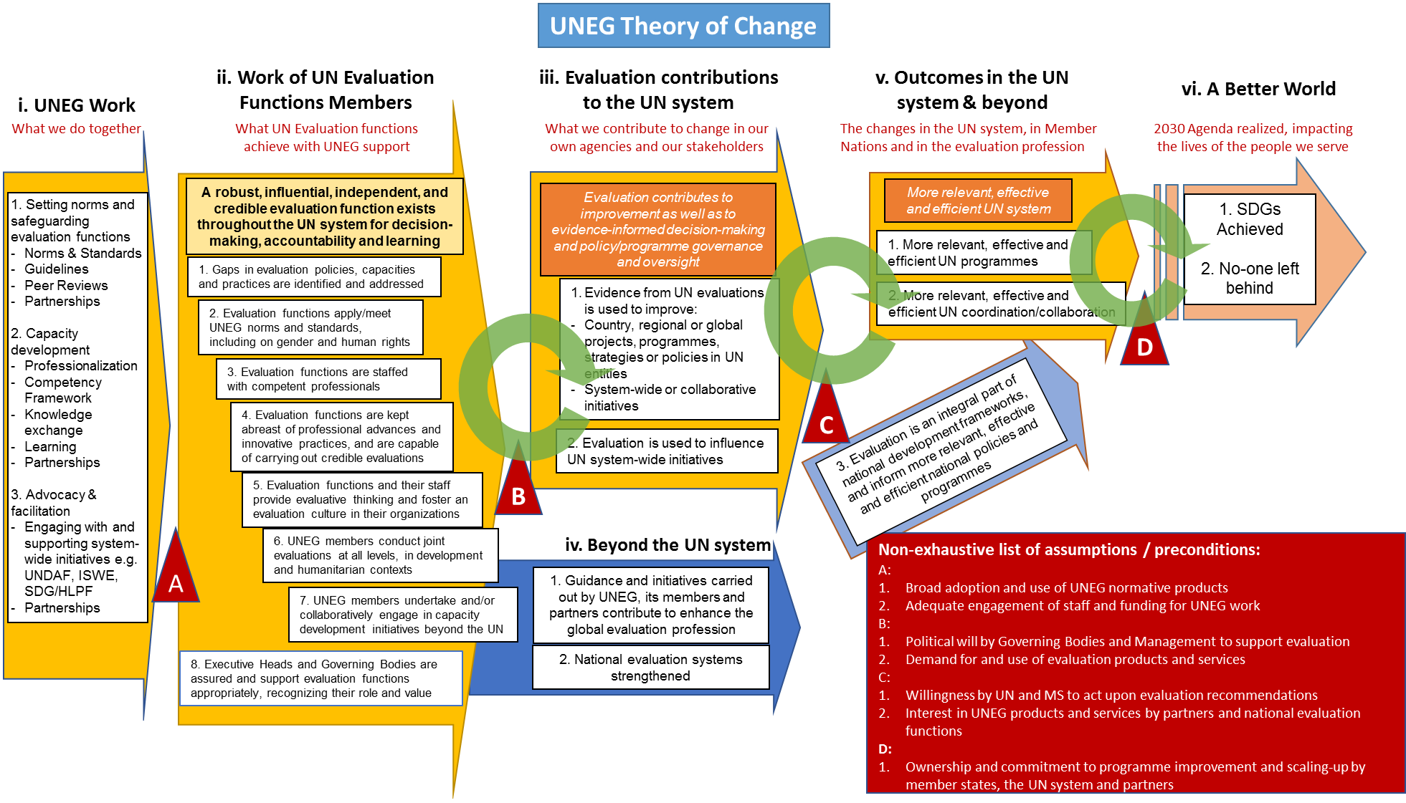

Indicator 2: To increase collaboration on joint and independent system-wide evaluation (ISWE) products to improve United Nations support on the ground. Indicator (QCPR – new): percentage of UNSDG Evaluation Offices (EO) engaging in joint or ISWE; Baseline 20 (2018): 10/35 or 29 percent of EOs have engaged in joint evaluations; Target (2021): 75 percent of EOs will have engaged in a joint evaluation; Baseline (2018): 7/35 or 20 percent have engaged on an ISWE product; Target (2021): 50 percent of EOs will have engaged in at least one ISWE.
Indicator 8: To improve the quality and utility of UNDAF evaluations Indicator (DCO): percentage of UNDAF evaluation reports with good or excellent rating on methodology used; Baseline (2016): 10/36 or 28 percent; Target (2021): 75 percent Indicator (DCO): percentage of UNDAF evaluations that contain all the following: actionable recommendations, with a clear target audience and timeframe for implementation, and a management response; Baseline (2016): 10/36 or 28 percent (23/62 for management response); Target (2021): 100 percent
Indicator 9: To increase accessibility of corporate evaluations and of internal audit reports, within the disclosure provisions and policies set by governing bodies at the time of report issuance Indicator (DCO): percentage of UNDS entities authorized within disclosure provisions and policies who have made their corporate evaluations available on the UNEG website; Baseline (2018): 10/48, or 21 percent; Target (2019): 100 percent Indicator (QCPR – new): percentage of internal audit reports issued in line with the disclosure provisions and policies set by the relevant governing bodies, which are available on a dedicated searchable UN-RIAS platform/website, pending availability of resources; Baseline 2018: 0; Target (2021): 100 percent Indicator (FMOG): percentage of inter-agency pooled funds posting evaluation reports on the UNEG website Baseline; Baseline (2018): 0 percent; Target (2019): 100 percent
E.g. on methodologies for the conduct of evaluations.
These are existing working groups, and not necessarily those to be formed for implementing the strategy.
These are existing working groups, and not necessarily those to be formed for implementing the strategy.
These are existing working groups, and not necessarily those to be formed for implementing the strategy.

